

|  |  |
| --- | --- |
| **COURSE TITLE:** | Software Project Management |
| **COURSE CODE:** | SE4140 |
| **INSTRUCTOR:** | Engr. Tanwi Nkiamboh |

NAME: Ndah Gilgar

MATRICULE: ICTU20223325

EMAIL: ndah.gilgar@ictuniversity.edu.cm

PHONE NUMBER: 676 80 10 63

**Task One: Project Charter for the 2025 Presidential Election in Cameroon**

# Objective

To conduct a fair, transparent, and efficient presidential election in Cameroon in 2025, to make sure that all eligible voters can participate and that the election process is honest

# Scope

The project will contain all aspects of the election process, including:

Voter Registration: Implementing a comprehensive system for registering eligible voters.

Campaign Monitoring: Establishing guidelines and oversight mechanisms for political campaigns.

Logistics: Coordinating the logistics of polling stations, voting materials, and transportation.

Result Announcement: Ensuring a transparent and timely process for counting votes and announcing results.

# Constraints

The project faces several challenges, including:

Time Limitations: A tight timeline for completing all preparatory activities before the election date.

Political Risks: Potential unrest or disputes among political parties or stakeholders.

Resource Constraints: Limited financial and human resources to execute the election effectively.

# Stakeholders

Key stakeholders involved in the project include:

Election Commission: Responsible for overseeing the election process and ensuring compliance with laws.

Political Parties: Contesting candidates and their representatives.

International Observers: Providing oversight to ensure fairness and transparency.

Media: Covering the election process and informing the public.

Voters: The general public, including all eligible citizens participating in the election.

# Approval Criteria

Success will be measured based on the following metrics:

Timely Execution: All phases of the project completed according to the established timeline.

Low Error Rate: Minimal discrepancies in voter registration and vote counting processes.

Minimal Disputes: Reducing the number of complaints or disputes related to the election process.

# Task 2 Stakeholder analysis

|  |  |  |
| --- | --- | --- |
| Power/Interest | Stakeholders | Engagement Strategies |
| High Power, High Interest | Election Commission, Presidential Candidates | Regular stakeholder meetings to discuss concerns and updates . - Involvement in decisionmaking processes.  - Transparent communication regarding progress and challenges. |
| High Power, Low Interest | Election Commission, Presidential Candidates | * Periodic briefings to keep them informed of key developments. - Ensure their support for necessary resources. * Highlight the importance of their role in facilitating the election. |
| Low Power, High Interest | General Voters | * Public awareness campaigns to educate voters about the election process. * Social media outreach to engage and inform. * Opportunities for community forums and Q&A sessions. |
| Low Power, Low Interest | Minor Observers | * Provide basic information on the election process. * Encourage their involvement in monitoring activities. |
|  |  | - Share reports or updates postelection to maintain transparency. |

**Summary of Strategies:**

* **High Power, High Interest**: Engage directly and involve in decision-making.
* **High Power, Low Interest**: Keep informed and leverage their resources.
* **Low Power, High Interest**: Educate and create awareness through outreach.
* **Low Power, Low Interest**: Provide basic information and encourage participation.

# Task 3: PERT Chart and critical path analysis

|  |  |  |  |  |  |  |
| --- | --- | --- | --- | --- | --- | --- |
| **Task** | **Predecessor(s)** | **Optimistic** | **Most Likely** | **Pessimistic** | **expected duration** | **variance** |
| **A: Budget Approval** | **-** | **1** | **2** | **3** | **2** | **1/9** |
| **B: Voter Registration** | **A** | **4** | **5** | **7** | **5** | **1/4** |
| **C: Campaign Monitoring** | **A** | **3** | **4** | **6** | **4** | **1/4** |
| **D: Logistics Planning** | **A** | **5** | **6** | **8** | **6** | **1/4** |
| **E: Equipment Procuremen** | **D** | **4** | **5** | **6** | **5** | **1/9** |
| **F: Training Staff** | **D** | **3** | **4** | **5** | **4** | **1/9** |
| **G: Election Day** | **B, E, F** | **1** | **2** | **3** | **2** | **1/9** |
| **H: Result Compilation** | **G** | **2** | **3** | **5** | **3** | **1/4** |

**NETWORK DIAGRAM:**

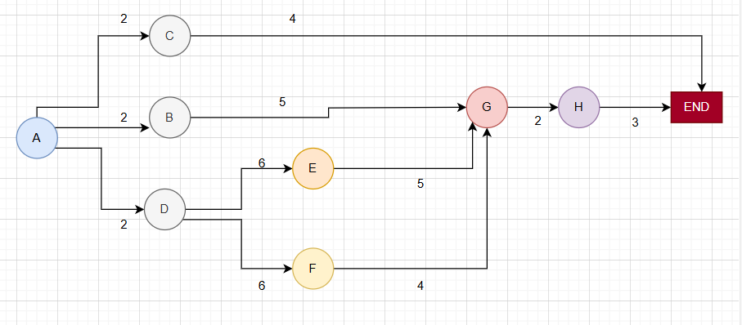

The

**Pert chart**

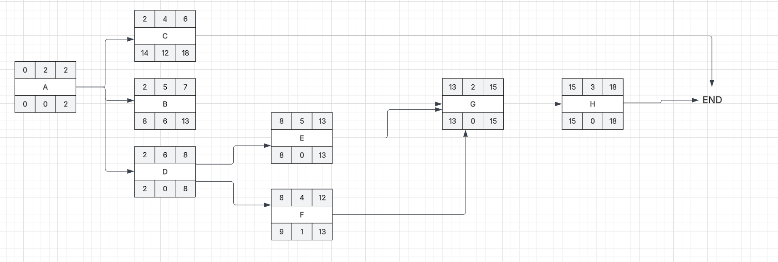

PATHS :

A+C = 6

A+B+G+H = 11

A+D+E+G+H = 18 Weeks (CRITICAL PATH)

A+D+F+G+H = 17 weeks

**project’s total expected duration** = 18

## Task 4: Gantt chart

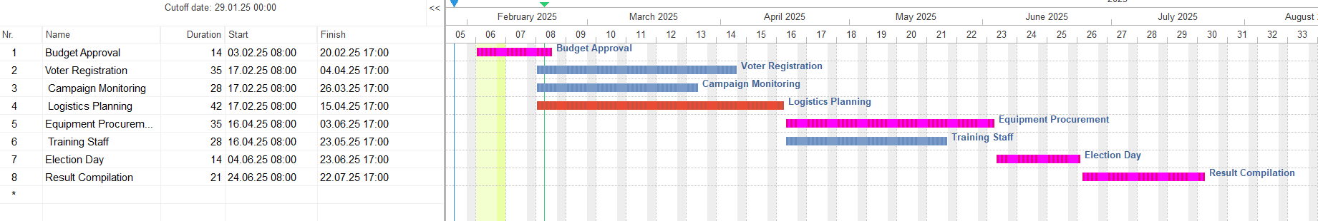

### Key Milestones

* **Week 3**: Start of Voter Registration
* **Week 11**: Election Day
* **Week 12**: End of Result Compilation

**Colour Coding**

* **Critical Path Tasks**: Highlighted in **blue**
* **Non-Critical Path Tasks**: Highlighted in **orange**

# Task 5: Risk Management Plan

|  |  |  |  |  |  |
| --- | --- | --- | --- | --- | --- |
| Risk | **Description** | Likelihood | Impact | **Mitigation Strategies** | **Contingency Plan** |
| 1. **Security**  **Issues** | Potential threats to the safety of voters and staff. | High | High | Coordinate with law enforcement for security presence. | Develop a crisis response plan in collaboration with local authorities. |
| 2.  **Logistical**  **Delays** | Delays in delivery of election materials and requirement | Medium | High | Establish relationships with multiple suppliers; track inventory closel | ave backup suppliers on standby and maintain a buffer stock of essential materials. |
| 3.  **Equipment**  **Failure** | Malfunction of voting machines or counting equipe | Medium | High | Regular maintenance checks and testing before election day. | Have a technical support team ready on election day to address issues quickly. |
| 4. **Voter**  **Apath** | Low voter turnout due to lack of interest or awareness. | Medium | Medium | Implement public awareness campaigns about the importance of voting. | Plan to extend voting hours or simplify voter engagement processes. |
| 5. **Political**  **Dispute** | Conflicts between  political parties leading to disputes. | High | Medium | Establish clear communication channels and guidelines for campaign monitoring. | Mediation processes in place to resolve disputes quickly. |

## Task 6: Budget Estimation and Allocation

|  |  |  |
| --- | --- | --- |
| Budget Category | Estimated Cost (in XAF) | Justification |
| 1. **Personnel Costs** | 300 million | overs salaries for election staff, including poll workers, security personnel, and administrative staff. Adequate staffing is crucial for smooth operations and security. |
| 2. **Logistics Costs** | 200 million | Includes transportation of materials, setup of polling venues, and other logistical needs. Ensures that all polling stations are adequately equipped and accessible. |
| 3. **Technology Costs** | 250 million | Encompasses the purchase or rental of voting machines, IT infrastructure, and technical support. Essential for ensuring a secure and efficient voting process. |
| 4. **Public Awareness**  **Campaigns** | 90 million | Funds for voter education campaigns, outreach programs, and promotional materials. Critical for increasing voter turnout and ensuring that citizens are informed about the election process. |
| 5. **Contingency Fund** | 80 million | Set aside as 10% of the total budget  ($1,350,000). This fund will cover unexpected expenses or emergencies that may arise during the election process. |

**Total Estimated Budget**

### | Total Estimated Budget 920 million xaf Justification Summary

1. **Personnel Costs**: High personnel costs are necessary to ensure that the election is adequately staffed, which directly impacts the election's success and security.
2. **Logistics Costs**: Logistics are critical to the election process, as they affect the timely setup and operation of polling stations.
3. **Technology Costs**: Investment in technology is vital to ensure a secure and efficient voting process, minimizing errors and enhancing voter trust.
4. **Public Awareness Campaigns**: Educating voters is essential for promoting participation and ensuring that voters understand the process, which can significantly affect turnout.
5. **Contingency Fund**: Allocating a contingency fund is prudent to address unforeseen circumstances, ensuring that the election can proceed smoothly even in the face of challenges.

### Task 7: Probability Analysis and Project Completion Time

1. Calculate the total variance for the critical path. :

A+D+E+G+H = 1/9 + 1/4 + 1/9 + 1/9 + 1/4

= 5/6

= 0.83

2. For a target project completion time of 18 weeks, calculate the Z-score:

Z-score = (x-u)/ standard deviation of critixal path

= (18 – 18)/0.83

= 0

3. Using a standard normal distribution (Z-table):  
For Z = 0, the probability is 0.5 or 50%

4. Interpretation and recommendations:

* A 50% probability means there's an equal chance of completing the project either before or after 18 weeks
* This is generally considered a risky probability for project planning

**Recommendations:**

* + Add buffer time to the schedule, perhaps targeting 19-20 weeks instead
  + Consider adding resources to critical path activities
  + Implement strict monitoring of critical path activities
  + Develop contingency plans for potential delays